A Project Report
on
SKIN LESION CLASSIFICATION
submitted in partial fulfillment of the requirements for the award of the degree of
BACHELOR OF TECHNOLOGY
in
COMPUTER SICENCE AND ENGINEERING

by
17WH1A0522 Ms. K.HARSHINI
17WH1A0543 Ms. V.PRAVALIKA
17WH1A0509 Ms. K.CHAITRA

under the esteemed guidance of
Mr. Y.MADAN REDDY
Assistant Professor



Department of Computer Science and Engineering
BVRIT HYDERABAD
College of Engineering for Women
(NBA Accredited – EEE, ECE, CSE and IT)
(Approved by AICTE, New Delhi and Affiliated to JNTUH, Hyderabad)
Bachupally, Hyderabad – 500090

May, 2021
DECLARATION

We hereby declare that the work presented in this project entitled “SKIN LESION CLASSIFICATION” submitted towards completion of Project Work in IV year of B.Tech., CSE at ‘BVRIT HYDERABAD College of Engineering For Women’, Hyderabad is an authentic record of our original work carried out under the guidance of Mr. Y.Madan Reddy, Assistant Professor, Department of CSE.

Sign. with date:
Ms. K.HARSHINI
(17WH1A0522)

Sign. with date:
Ms. V.PRAVALIKA
(17WH1A0543)

Sign. with date:
Ms. K.CHAITRA
(17WH1A0509)

BVRIT HYDERABAD
College of Engineering for Women
(NBA Accredited – EEE, ECE, CSE and IT)
(Approved by AICTE, New Delhi and Affiliated to JNTUH, Hyderabad)
Bachupally, Hyderabad – 500090

Department of Computer Science and Engineering



Certificate

This is to certify that the Project Work report on “SKIN LESION CLASSIFICATION” is a bonafide work carried out by Ms.K.HARSHINI (17WH1A0522), Ms.V.PRAVALIKA (17WH1A0543), Ms.K.CHAITRA (17WH1A0509) in the partial fulfillment for the award of B.Tech. degree in Computer Science and Engineering, BVRIT HYDERABAD College of Engineering for Women, Bachupally, Hyderabad, affiliated to Jawaharlal Nehru Technological University Hyderabad, Hyderabad under my guidance and supervision.

The results embodied in the project work have not been submitted to any other University or Institute for the award of any degree or diploma.

Head of the Department Guide
Dr. K.Srinivasa Reddy Mr.Y.Madan Reddy
Professor and HoD, Assistant Professor
Department of CSE Department of CSE

External Examiner
Acknowledgements

We would like to express our sincere thanks to Dr. K V N Sunitha, Principal, BVRIT HYDERABAD College of Engineering for Women, for providing the working facilities in the college.

Our sincere thanks and gratitude to our Dr. K.Srinivasa Reddy, Professor, Department of CSE, BVRIT HYDERABAD College of Engineering for Women for all the timely support and valuable suggestions during the period of our project.

We are extremely thankful and indebted to our internal guide, Mr. Y.Madan Reddy, Assistant Professor, Department of CSE, BVRIT HYDERABAD College of Engineering for Women for his constant guidance, encouragement and moral support throughout the project.

Finally, we would also like to thank our Project Coordinator, all the faculty and staff of CSE Department who helped us directly or indirectly, parents and friends for their cooperation in completing the project work.

Ms. K.HARSHINI
(17WH1A0522)

Ms. V.PRAVALIKA
(17WH1A0543)

Ms. K.CHAITRA
(17WH1A0509)

Contents

S.No. | Topic | Page No.
 | Abstract | i
 | List of Figures | ii
1. | Introduction | 1
 | 1.1 Objectives | 1
 | 1.2 Methodology | 2
 | 1.2.1 Dataset | 2
 | 1.2.2 The proposed CNN model | 4
 | 1.3 Organization of Project | 9
2. | Theoretical Analysis of the proposed project | 10
 | 2.1 Requirements Gathering | 10
 | 2.1.1 Software Requirements | 10
 | 2.1.2 Hardware Requirements | 10
 | 2.2 Technologies Description | 10
3. | Design | 14
 | 3.1 Introduction | 14
 | 3.2 Architecture Diagram | 14
 | 3.3 UML Diagrams | 16
 | 3.3.1 Use Case Diagram | 16
 | 3.3.2 Sequence Diagram | 17
 | 3.3.3 Activity Diagram | 18
 | 3.3.4 Collaboration Diagram | 19
 | 3.3.5 Class Diagram  3.4 Phases of project | 20  21
4. | Implementation | 22
 | 4.1 Neural network coding  4.1.1 Importing essential packages  4.1.2 Loading dataset  4.1.3 Reducing memory usage  4.1.4 Expanding dataset  4.1.5 Data preprocessing  4.1.6 EDA  4.1.7 Train – Test split  4.1.8 Normalisation  4.1.9 MobileNet CNN model building  4.1.10 Training the model  4.1.11 Calculating accuracy  4.1.12 Plotting confusion matrix | 22  22  22  23  24  25  25  28  28  29  31  31  32
 | 4.2 UI coding | 34
 | 4.2.1 Importing essential packages  4.2.2 Prediction code  4.2.3 User Interface | 34  34  35
 | 4.3 Testing  4.3.1 Test Cases | 36  36
 | 4.4 Dataset Training Images | 37
 | 4.5 Input Images | 38
 | 4.6 Output Images | 40
5. | Conclusion and Future Scope | 41
6. | References | 42

ABSTRACT

Melanoma is deadly skin cancer. There is a high similarity between different kinds of skin lesions, which leads to incorrect classification. Accurate classification of a skin lesion in its early stages saves human life. This project aims at classifying skin lesion images into seven classes namely melanoma, melanocytic nevus, basal cell carcinoma, actinic keratosis, benign keratosis, dermato fibroma, and vascular lesion using deep convolutional neural networks (CNNs) with mobilenet architecture. In this a lesion image from dataset is taken as input and is expected to give the type of lesion as output.
i
LIST OF FIGURES

S.No. | Fig No. | Fig Name | Page No.
1. | 1.2.1 | Sample images of HAM10000 dataset | 2
2. | 1.2.1.1 | Metadata file | 3
3. | 1.2.1.2 | Data Preprocessing Cleaning | 3
4. | 1.2.2.1 | Mobile Net Blocks | 4
5.  6.  7.  8.  9.  10. | 1.2.2.2  1.2.2.3  1.2.2.4  1.2.2.5  1.2.2.6 | Mobile Net Architecture  Depthwise vs standard convolution layers  Batch Normalisation layer  MaxPooling layer  Flattening layer | 5  6  6  7  7
11. | 3.2.1 | Architecture Diagram | 15
12. | 3.3.1 | Use Case Diagram | 16
13. | 3.3.2 | Sequence Diagram | 17
14. | 3.3.3 | Activity Diagram | 18
15. | 3.3.4 | Collaboration Diagram | 19
16.  17. | 3.3.5  3.4.1 | Class Diagram  Phases | 20  21
18. | 4.1.1 | Memory reduce | 24
19. | 4.1.2 | Expanding Data set | 24
20. | 4.1.3 | Bar Graph of comparing Lesion | 25
21. | 4.1.4 | Bar Graph of comparing tests | 26
22. | 4.1.5 | Bar Graph for Localization | 26
23. | 4.1.6 | Histogram for Plotting age Vs Count of people with Lesion | 27
24. | 4.1.7 | Bar Graph for comparing Gender Vs people with Lesion | 27
25. | 4.1.8 | Scatterplot Age Vs Lesion type | 28
26. | 4.1.9 | Mobile Net Model | 30
27. | 4.1.10 | Calculating Accuracy | 31  ii
28. | 4.1.11 | Confusion Matrix | 33
29. | 4.3.1 | Test cases | 36
30. | 4.4.1 | Data set Training Images | 37
31. | 4.5.1 | Command to run the Project | 38
32.  33.  34.  35.  36. | 4.5.2  4.5.3  4.5.4  4.6.1  4.6.2 | Upload the images  Selecting file to upload image  Selecting Image to upload  Predicting Lesion Type(1)  Predicting Lesion Type(2) | 38  39  39  40  40

iii
1. INTRODUCTION

Skin cancer, a major form of cancer, is a critical public health problem with 123,000 newly diagnosed melanoma cases and between 2 and 3 million non-melanoma cases worldwide each year. The leading cause of skin cancer is high exposure of skin cells to UV radiation, which can damage the DNA inside skin cells leading to uncontrolled growth of skin cells. Skin cancer is primarily diagnosed visually employing clinical screening, a biopsy, dermoscopic analysis, and histopathological examination. It has been demonstrated that the dermoscopic analysis in the hands of inexperienced dermatologists may cause a reduction in diagnostic accuracy. This project aims at classifying skin lesion images into seven classes namely melanoma, melanocytic nevus, basal cell carcinoma, actinic keratosis, benign keratosis, dermatofibroma, and vascular lesion using deep convolutional neural networks (CNNs) with mobilenet architecture. A CNN tries to mimic the process of recognition of images by the visual cortex in the brain. For better results in image classification, feature extraction is used according to machine learning tasks. In CNN architecture there are multiple convolution layers followed by a stack of pooling layers, then contrast normalization layers. In the end, there is at least one fully connected layer. A CNN is less dense and can easily be trained compared to the feed-forward network. However, the best performance of CNNs is slightly lower and more computationally heavy on high-resolution images than the feed-forward network.

1.1 Objectives
Identifying skin lesions is time-consuming and often leads to incorrect classification. This sometimes leads to the late discovery of deadly skin cancer. Hence, accurate and fast classification of a skin lesion in its early stages can save someone's life. Skin lesion classification aims at identifying different kinds of skin lesions anywhere on a person's body. Skin cancer is a major threat to humans and can sometimes lead to death, but their quick identification remains difficult. Using the HAM10000 dataset containing seven types of lesion classifications, we train a deep convolutional neural network to identify the type of skin lesion.

1.2 Methodology
To classify lesions, a large collection of skin lesion images on different parts of the body is required. The dataset is downloaded from Kaggle. In this section the methodology followed is discussed in detail.
1.2.1 Dataset
The dataset for the experiment is downloaded from Kaggle which contains different skin lesion images and their labels. It contains a collection of images taken from different people, present on different parts of their bodies. The dataset consists of a total of 10015 dermoscopy images, which are released as a training set for academic machine learning purposes and are publicly available through the ISIC archive. It includes 6705 Melanocytic nevi images, 1113 Melanoma images, 1099 Benign keratosis images, 514 Basal cell carcinoma images, 327 Actinic keratosis images, 142 Vascular images, and 115 Dermatofibroma images with 600 x 450 pixels resolution.
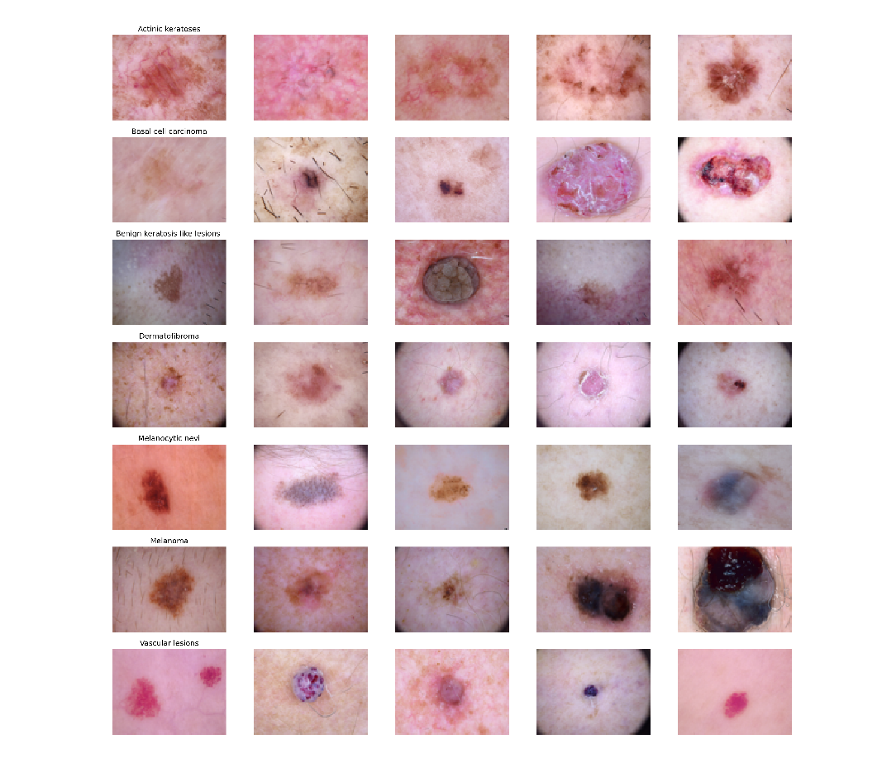 Fig. 1.2.1 Sample images from HAM10000 dataset for cancer types (a) Actinic Keratosis (b) Basal Cell Carcinoma (c) Benign Keratosis (d) Dermatofibroma (e) Melanocytic nevi (f) Melanoma (g) Vascular Lesions
The dataset includes lesions with multiple images, which can be tracked by the lesion_id column within the HAM10000_metadata file. Which contains 7 attributes namely lesion_id, image_id, dx, dx_type, age, sex, localization.

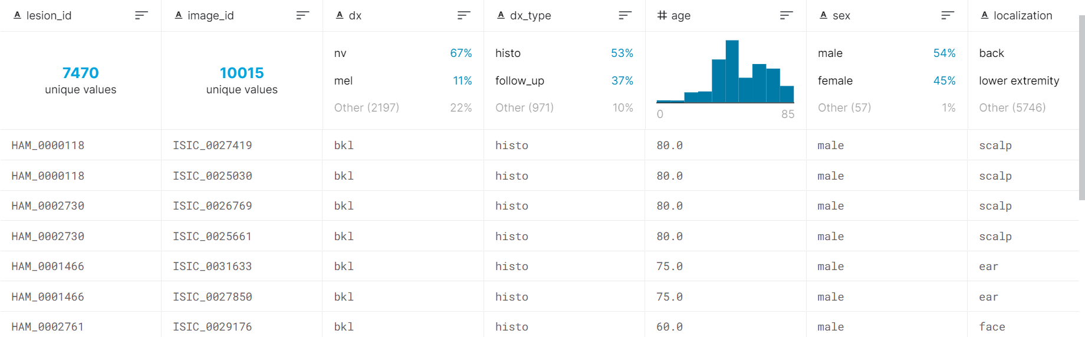

Fig. 1.2.2 Metadata file

Data pre-processing and cleaning
We found there were 57 null age entries in the dataset which were filled using the mean filling method. The images were resized into 224 x 224 as the original dimension of images is 450 x 600 cannot be handled by TensorFlow.
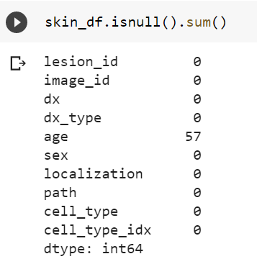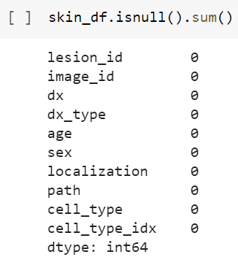
Fig.1.2.1.2 Data preprocessing and cleaning
Data Augmentation
This step is required to avoid the over fitting problem. For this, we need to expand our HAM 10000 dataset artificially. Approaches that alter the training data in ways that change the array representation while keeping the label the same are known as data augmentation. For the data augmentation, random rotation of some training images by 10 degrees, random zoomingof some training images by 10%, random shifting of images horizontally by 10% of the width, random shifting of images vertically by 10% of the height were implemented.
Train-Test Split
The 10015 images in the dataset were split into training and testing sets of 80:20 ratio. Then the train set was split into two parts: a small fraction (10%) became the validation set which the model evaluated and the rest (90%) is used to train the model.
Fitting the model
In this step, the model is fit into x_train, y_train. Then they are sent to fit_generator function with optimal batch_size and epochs required to train the model sufficiently.

1.2.2 The proposed CNN model with MobileNet architecture
We initially implemented a sequential CNN model with a few of 12 layers being 4 Conv2D layers, 2 MaxPooling2D layers, 3 Dropout, Flatten and Dense layers. But later changed it to MobileNet architecture for better accuracy. MobileNet in total consists of 25 layers, which employs 4 Conv2D layers, 7 BatchNormalization layers, 7 ReLU layers, 3 ZeroPadding2D layers, and 1 DepthwiseConv2D, GlobalAveragePooling, Dropout, and Dense layers. Whole model is built from carefully repeating a set of MobileNet blocks with different filter and strides values.
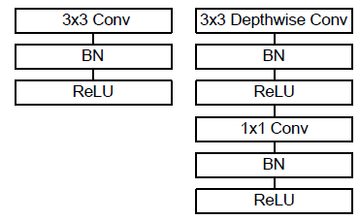
Fig.1.2.2.1 MobileNet blocks
For MobileNets the depthwise convolution applies a single filter to each input channel. The pointwise convolution then applies a 1×1 convolution to combine the outputs the depthwise convolution. A standard convolution both filters and combines inputs into a new set of outputs in one step. The depthwise separable convolution splits this into two layers, a separate layer for filtering and a separate layer for combining. This factorization has the effect of drastically reducing computation and model size.

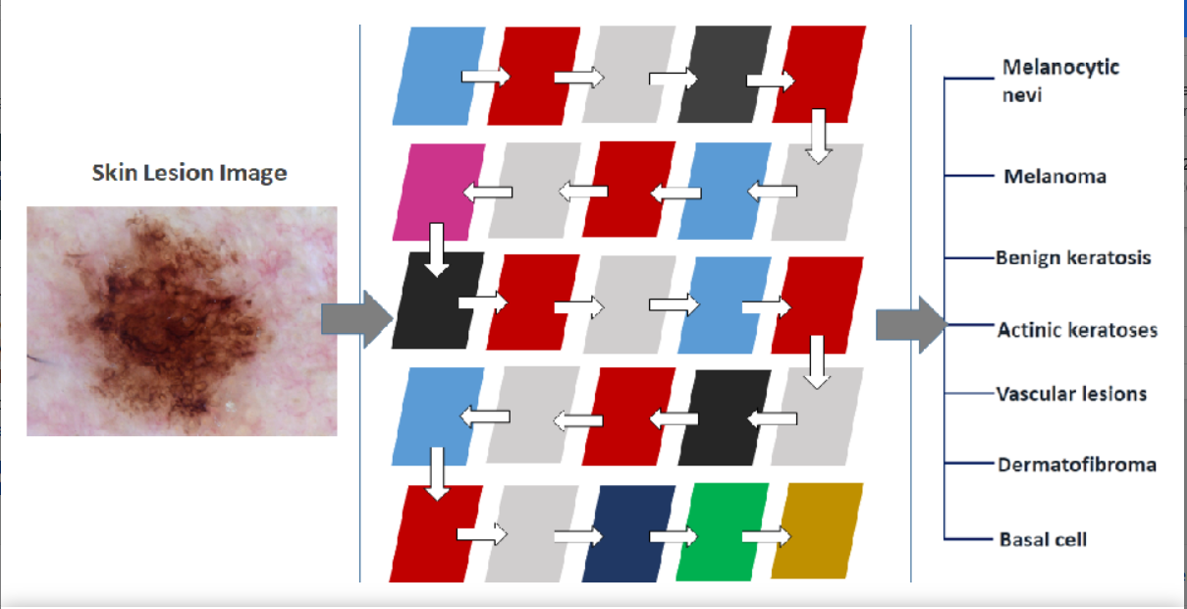

Fig.1.2.2.2 MobileNet Architecture

Main layers of MobileNet architecture
Convolution: The term convolution refers to the mathematical combination of two functions to produce a third function. In the case of a CNN, the convolution is performed on the input data with the use of a filter to then produce a feature map.
Depthwise Convolution: Depthwise convolution is a type of convolution in which a single convolutional filter is apply to each input channel (i.e. in a depthwise way). You can understand depthwise convolution as being the first step in a depthwise separable convolution.

It is implemented via the following steps:
- Split the input into individual channels.
- Convolve each input with the layer's kernel (called a depthwise kernel).
- Stack the convolved outputs together (along the channels axis).

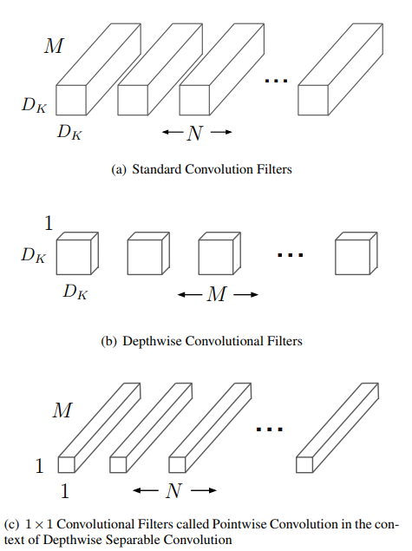

Fig.1.2.2.3 Depthwise vs standard convolution layers

Batch Normalisation: Layer that normalizes its inputs. Batch normalization applies a transformation that maintains the mean output close to 0 and the output standard deviation close to 1. Importantly, batch normalization works differently during training and during inference.
During training, the layer normalizes its output using the mean and standard deviation of the current batch of inputs. During inference, the layer normalizes its output using a moving average of the mean and standard deviation of the batches it has seen during training.
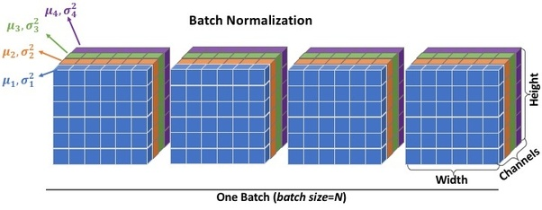

Fig.1.2.2.4 Batch Normalisation layer

Applying ReLu(Rectified Linear Unit): In this step we apply the rectifier function to increase non-linearity in the CNN. Images are made of different objects that are not linear to each other. Without applying this function the image classification will be treated as a linear problem while it is actually a non-linear one.

Max pooling: Max pooling is a sample-based discretization process. The objective is to down-sample an input representation (image, hidden-layer output matrix, etc.), reducing its dimensionality and allowing for assumptions to be made about features contained in the sub-regions binned.
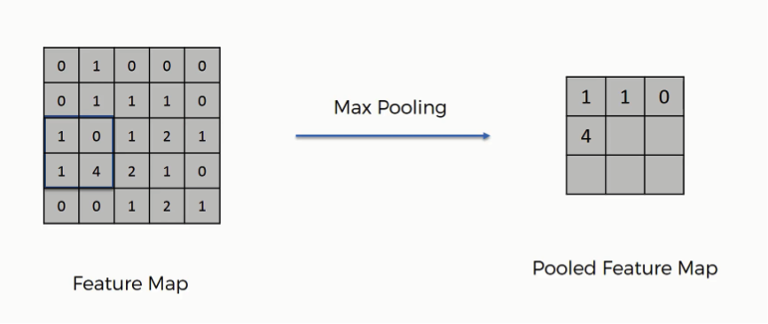
Fig.1.2.2.5 MaxPooling layer

Flattening: Once the pooled featured map is obtained, the next step is to flatten it. Flattening involves transforming the entire pooled feature map matrix into a single column which is then fed to the neural network for processing. Flattening is also known as the process of converting all the resultant 2 dimensional arrays into a single long continuous linear vector.

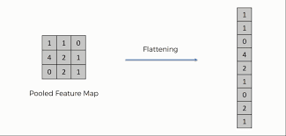

Fig.1.2.2.6 Flattening layer

Dropout: Dropout is a regularization method that approximates training a large number of neural networks with different architectures in parallel.
During training, some number of layer outputs are randomly ignored or “dropped out.” This has the effect of making the layer look-like and be treated-like a layer with a different number of nodes and connectivity to the prior layer. In effect, each update to a layer during training is performed with a different “view” of the configured layer.
By dropping a unit out, we mean temporarily removing it from the network, along with all its incoming and outgoing connections
Dropout has the effect of making the training process noisy, forcing nodes within a layer to probabilistically take on more or less responsibility for the inputs.
Dense: The dense layer is a neural network layer that is connected deeply, which means each neuron in the dense layer receives input from all neurons of its previous layer. The dense layer is found to be the most commonly used layer in the models.
In the background, the dense layer performs a matrix-vector multiplication. The values used in the matrix are actually parameters that can be trained and updated with the help of back propagation.
The output generated by the dense layer is an ‘m’ dimensional vector. Thus, dense layer is basically used for changing the dimensions of the vector. Dense layers also applies operations like rotation, scaling, translation on the vector.
Full Connection: At the end of a CNN, the output of the last Pooling Layer acts as a input to the so called Fully Connected Layer. There can be one or more of these layers (“fully connected” means that every node in the first layer is connected to every node in the second layer).

1.3 Organization of Project
For this project, a lesion image from the dataset is taken as input and expected to give the type of lesion using a convolutional neural network. According to the input image, lesion name / type, its index number path of the image is given.

2. THEORTICAL ANALYSIS OF THE PROPOSED PROJECT
2.1 Requirements Gathering
2.1.1 Software Requirements
Programming Language : Python 3.6+
Graphical User Interface : Tkinter
Dataset : HAM10000 Dataset
Packages :Numpy, Pandas, Matplotlib, Scikit-learn, Keras, Tensorflow
IDE : Google Colab
2.1.2 Hardware Requirements
Operating System : Windows 7+, Ubuntu
Processor : Intel Core i3-2348M
CPU Speed : 2.30 GHz
RAM : 4 GB

2.2 Technologies Description
Python
Python is an interpreted high-level general-purpose programming language, has design philosophy emphasizes code readability with it’s notable use of significant indentation, the recommended indent size is four spaces. Developed by Guido van Rossum in the late 1980’s and first released in 1991. Python strives for a simpler, less-cluttered syntax and grammar. Python is used for developing web applications, data science and for rapid application development. Python is portable, extensible, embeddable and scalable.
Tensorflow
TensorFlow is a free and open-sourcesoftware library for machine learning, based on dataflow and differentiable programming across a range of tasks. It is a symbolic math library. It is also used for machine learning applications such as neural networks. It is used for both research and production at Google. TensorFlow accepts data in the form of multi-dimensional arrays of higher dimensions called tensors.
It was developed by the Google Brain team for internal Google use and was released under the Apache License 2.0 in 2015. Google released Colaboratory, which is a TensorFlow Jupyter notebook environment that requires no setup to use.
Keras:
Keras is an open-sourcesoftware library that provides a Python interface for artificial neural networks. It is a deep learning API. It runs on top of the machine learning platform Tensorflow. It is user-friendly, modular, and extensible. It acts as an interface for the TensorFlow library.
The core data structures of Keras are layers and models. It contains numerous implementations of commonly used neural-network building blocks such as layers, objectives, activationfunctions, optimizers, and a host of tools to make working with image and text data easier to simplify the coding necessary for writing deep neural network code.
Numpy
Numpy is a general-purpose array-processing package. It provides a high-performance multidimensional array object, and tools for working with these arrays.
It is the fundamental package for scientific computing with Python. It contains various features including these important ones:
- A powerful N-dimensional array object
- Sophisticated (broadcasting) functions
- Tools for integrating C/C++ and Fortran code
- Useful linear algebra, Fourier transform, and random number capabilities
Besides its obvious scientific uses, Numpy can also be used as an efficient multi-dimensional container of generic data. Arbitrary data-types can be defined using Numpy which allows Numpy to seamlessly and speedily integrate with a wide variety of databases.
Pandas
Pandas is an open-source Python Library providing high-performance data manipulation and analysis tool using its powerful data structures. Python was majorly used for data and preparation. It had very little contribution towards data analysis. Pandas solved this problem. Using Pandas, we can accomplish five typical steps in the processing and analysis of data, regardless of the origin of data load, prepare, manipulate, model, and analyze. Python with Pandas is used in a wide range of fields including academic and commercial domains including finance, economics, Statistics, analytics, etc.
Scikit – learn
Scikit-learn provides a range of supervised and unsupervised learning algorithms via a consistent interface in Python. It is licensed under a permissive simplified BSD license and is distributed under many Linux distributions, encouraging academic and commercial use. The library is built upon the SciPy (Scientific Python) that must be installed before you can use scikit-learn.
Google Colaboratory
Colaboratory, or “Colab” for short, is a product from Google Research. Colab allows anybody to write and execute arbitrary python code through the browser, and is especially well suited to machine learning, data analysis and education.
Colab is a free Jupyter notebook environment that runs entirely in the cloud.
Google Colab allows to:
- Write and execute code in Python
- Document your code that supports mathematical equations
- Create/Upload/Share notebooks
- Import/Save notebooks from/to Google Drive
- Import/Publish notebooks from GitHub
- Import external datasets e.g. from Kaggle
- Integrate PyTorch, TensorFlow, Keras, OpenCV
Colab works with most major browsers, and is most thoroughly tested with the latest versions of Chrome, Firefox and Safari.
Tkinter
Tkinter is the de facto way in Python to create Graphical User interfaces and is included in all standard Python Distributions.This Python framework provides an interface to the Tk toolkit and works as a thin object-oriented layer on top of Tk.The Tk toolkit is a cross-platform collection of ‘graphical control elements’, aka widgets, for building application interfaces.
This framework provides Python users with a simple way to create GUI elements using the widgets found in the Tk toolkit. Tk widgets can be used to construct buttons, menus, data fields, etc. in a Python application. Once created, these graphical elements can be associated with or interact with features, functionality, methods, data or even other widgets.
PIL Pillow (Python Imaging Library)
The Python Imaging Library adds image processing capabilities to your Python interpreter. This library provides extensive file format support, an efficient internal representation, and fairly powerful image processing capabilities. The core image library is designed for fast access to data stored in a few basic pixel formats. It should provide a solid foundation for a general image processing tool.
3. DESIGN
3.1 Introduction

Software design sits at the technical kernel of the software engineering process and is applied regardless of the developmental paradigm and area of application. Design is the first step in the developmental phase for any engineered product or system. The designer’s goal is to produce a model or representation of an entity that will later be built. Beginning, once system requirement have been specified and analyzed, system design is the first of the three technical activities – design, code and test.
The importance can be stated with a single word “Quality”. Design is the place where quality is fostered in software development. Design provides us with representations of software that can assess for quality. Design is the only way that we can accurately translate a customer’s view into a finished software product or system. Software design serves as a foundation for all the software engineering steps that follow. Without a strong design we risk building an unstable system – one that will be difficult to test, one whose quality cannot be assessed until the last stage. During design, progressive refinement of data structure, program structure and procedural details are developed reviewed and documented. System design can be viewed from either technical or project management perspective. From the technical point of view, design is comprised of four activities – architectural design, data structure design, interface design and procedural design.

3.2 Architecture Diagram

Web applications are by nature distributed applications, meaning that they are programs that run on more than one computer and communicate through network or server; specifically web applications are accessed with a web browser and are popular because of the ease of using the browser as a user client. For the enterprise, software on potentially thousands of client computers is a key reason for their popularity. Web applications are used for web mail, online retail sales, discussion boards, web logs, online banking, etc. One web application can be accessed and used by millions of people.
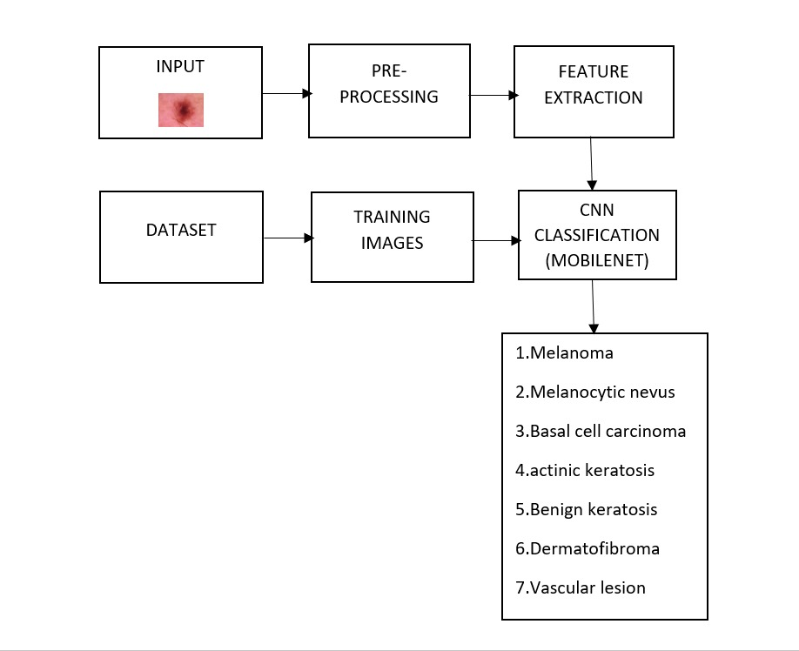

Fig.3.2 Architecture Diagram

3.3 UML Diagrams
3.3.1 Use Case Diagram

To model a system, the most important aspect is to capture the dynamic behavior. Dynamic behavior means the behavior of the system when it is running / operating.
Only static behavior is not sufficient to model a system rather dynamic behavior is more than static behavior. In UML, there are five diagrams available to model the dynamic nature and use case diagram is one of them. Now as we have to discuss that the use case diagram is dynamic in nature, there should be some internal or external factors for making the interaction.
These internal and external agents are known as actors. Use case diagrams consist of actors, use cases and their relationships. The diagram is used to model the system / subsystem of an application. A single use case diagram captures a particular functionality of a system.

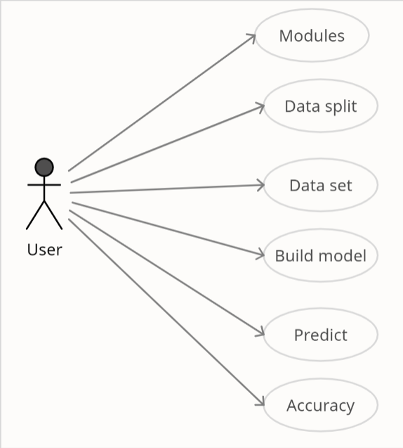

Fig.3.3.1 Usecase Diagram

3.3.2 Sequence Diagram

Sequence Diagram represents the objects that participate in the interactions horizontally and time vertically. We can also use the terms event diagrams or event scenarios to refer to a sequence diagram. Sequence diagrams describe how and in what order the objects in a system function. These diagrams are widely used by businessmen and software developers to document and understand requirements for new and existing systems.

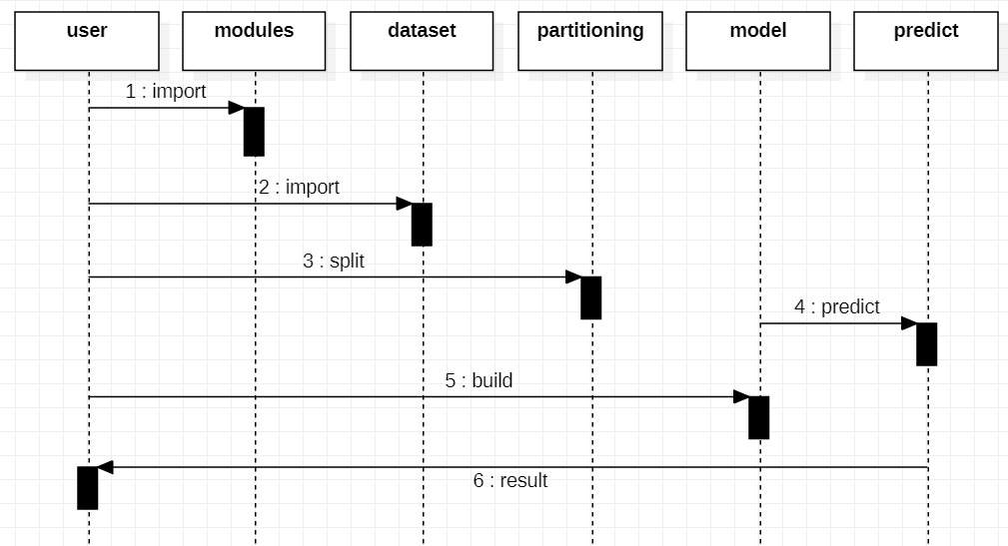

Fig.3.3.2 Sequence Diagram

3.3.3 Activity Diagram

Activity diagrams are graphical representations of Workflows of stepwise activities and actions with support for choice, iteration and concurrency. In the Unified Modeling Language, activity diagrams can be used to describe the business and operational step-by-step workflows of components in a system. An activity diagram shows the overall flow of control.

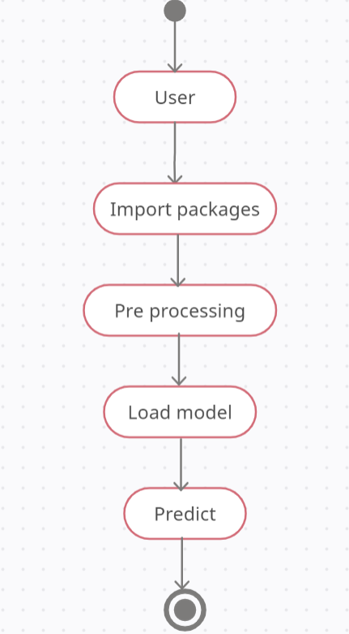

Fig3.3.3 Activity Diagram

3.3.4 Collaboration Diagram

A collaboration diagram resembles a flowchart that portrays the roles, functionality and behavior of individual objects as well as the overall operation of the system in real time. Objects are shown as rectangles with naming labels inside. These labels are preceded by colons and may be underlined. The relationships between objects are shown as arrows connecting the relevant rectangles along with labels that define the message sequencing.

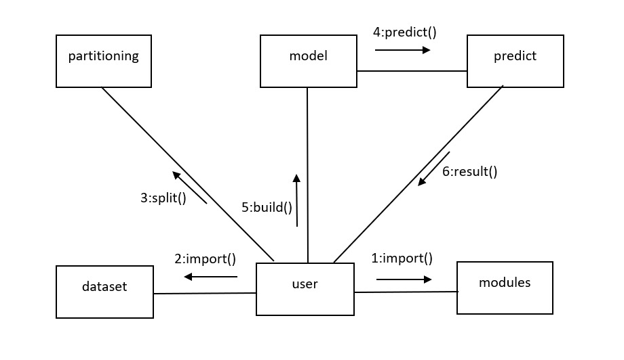

Fig.3.3.4 Collaboration Diagram
3.3.5 Class Diagram

The class diagram is the main building block of object-oriented modeling. It is used for general conceptual modeling of the systematic of the application, and for the detailed modeling translating the models into programming code. Class diagrams can also be used for data modeling. The classes in a class diagram represent both the main elements, interactions in the applications, and the classes to be programmed.

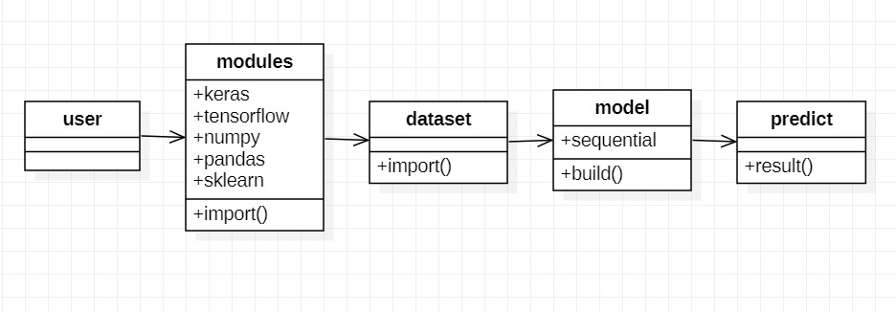

Fig.3.3.5 Class Diagram

3.4 Phases of project

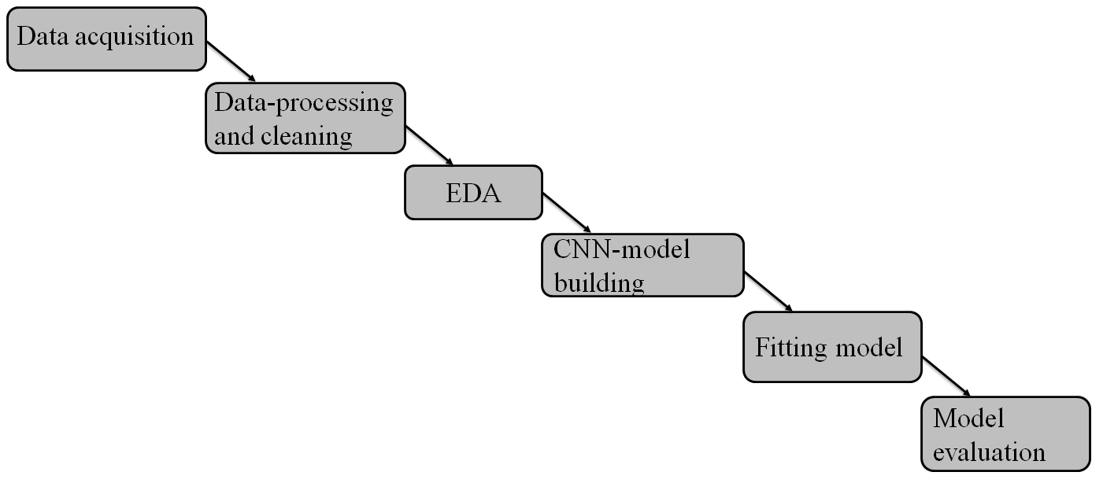
Fig.3.4.1 Phases

The first and foremost step is data accquisation, where we took the dataset "HAM10000" from kaggle like discussed previously.
Next is data processing and cleaning, where we tried finding any anomalies in the dataset and tried correcting, for example age column had 57 null values which we replaced by the column mean value.
Next is EDA - Explaratory Data Analysis , here we tried analysing our dataset using visualization tools like matplotlib. The aim of this step was to understand our dataset in a more statistical way.
Next is CNN model building . Initially we built a regular sequential model with a few of 12 layers, but later changed it to mobilenet architecture comprising of 25 layers.
Next is fitting the model. This step was performed to prevent the model from overfitting we have implemented LRAnnealation and Data Augumentation.
Next is model evaluation. After performing all these we got test accuracy to be 79% and validation accuracy as 81%.
4. IMPLEMENTATION
4.1 Neural network coding
4.1.1 Importing essential packages
import numpy as np
import pandas as pd import
matplotlib.pyplot as plt
import seaborn as sns
import os from glob
import glob
from PIL import Image
from sklearn.preprocessing
import label_binarize from sklearn.metrics
import confusion_matrix
import itertools
import keras
from keras.utils.np_utils import to_categorical
from keras.models import Sequential
from keras.layers import Dense, Dropout, Flatten, Conv2D, MaxPool2D
from keras import backend as K
import itertools
from keras.layers.normalization import BatchNormalization
from keras.utils.np_utils import to_categorical
from keras.optimizers import Adam
from keras.preprocessing.image import ImageDataGenerator
from keras.callbacks import ReduceLROnPlateau
from sklearn.model_selection import train_test_split

4.1.2 Loading dataset
skin_df=
pd.read_csv("/content/drive/MyDrive/skinLesionDataset/HAM10000_metadata.csv")
base_path = "/content/drive/MyDrive/skinLesionDataset/images"
imageid_path_dict = {}
for x in glob(os.path.join(base_path, '*', '*.jpg')):
imageid_path_dict[os.path.splitext(os.path.basename(x))[0]] = x

4.1.3 Reducing memory usage
def reduce_mem_usage(df, verbose=True):
numerics = ['int16', 'int32', 'int64', 'float16', 'float32']
start_mem = df.memory_usage().sum() / 1024**2
for col in df.columns:
col_type = df[col].dtypes
if col_type in numerics:
c_min = df[col].min()
c_max = df[col].max()
if str(col_type)[:3] == 'int':
if c_min > np.iinfo(np.int8).min and c_max < np.iinfo(np.int8).max:
df[col] = df[col].astype(np.int8)
elif c_min > np.iinfo(np.int16).min and c_max < np.iinfo(np.int16).max:
df[col] = df[col].astype(np.int16)
elif c_min > np.iinfo(np.int32).min and c_max < np.iinfo(np.int32).max:
df[col] = df[col].astype(np.int32)
elif c_min > np.iinfo(np.int64).min and c_max < np.iinfo(np.int64).max:
df[col] = df[col].astype(np.int64)
else:
if c_min > np.finfo(np.float16).min and c_max < np.finfo(np.float16).max:
df[col] = df[col].astype(np.float16)
elif c_min> np.finfo(np.float32).min and c_max < np.finfo(np.float32).max:
df[col] = df[col].astype(np.float32)
else:
df[col] = df[col].astype(np.float64)
end_mem = df.memory_usage().sum() / 1024**2
print('Memory usage after optimization is: {:.2f} MB'.format(end_mem))
print('Decreased by {:.1f}%'.format(100 * (start_mem - end_mem) / start_mem))
return df
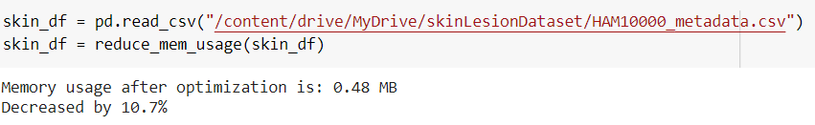
Fig4.1.1 Memory reduce

4.1.4 Expanding dataset
lesion_type_dict = {
'nv': 'Melanocytic nevi',
'mel': 'Melanoma',
'bkl': 'Benign keratosis-like lesions ',
'bcc': 'Basal cell carcinoma',
'akiec': 'Actinic keratoses',
'vasc': 'Vascular lesions',
'df': 'Dermatofibroma'
}
skin_df['path'] = skin_df['image_id'].map(imageid_path_dict.get)
skin_df['cell_type'] = skin_df['dx'].map(lesion_type_dict.get)
skin_df['cell_type_idx'] = pd.Categorical(skin_df['cell_type']).codes

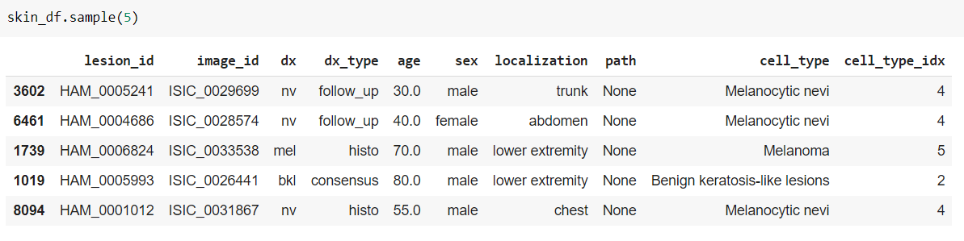
Fig.4.1.2 Extended dataset

4.1.5 Data preprocessing
Data Cleaning
skin_df.isnull().sum()
skin_df[‘age’].fillna((skin_df[‘age’].mean()), inplace=True)
Resizing images according to tensorflow passable size
skin_df[‘image] = skin_df[‘path’].map(lambda x: np.asarray(Image.open(x).resize((224, 224))))

4.1.6 EDA

#Comparing number of cases of each lesion
fig, ax1 = plt.subplots(1, 1, figsize= (10, 5))
skin_df['cell_type'].value_counts().plot(kind='bar', ax=ax1)

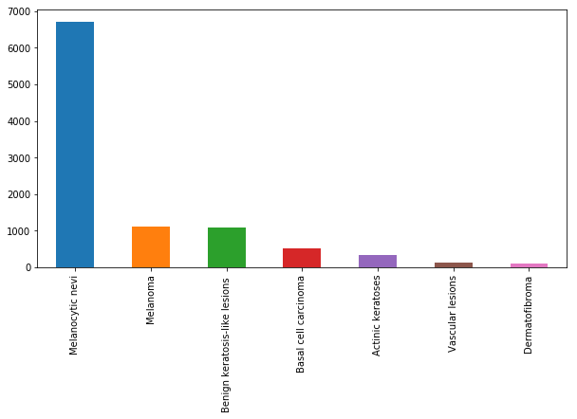
Fig.4.1.3 Bar Graph of comparing Lesion

#Comparing tests counts
skin_df[‘dx_type’].value_counts().plot(kind=’bar’)
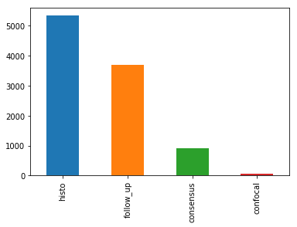
Fig. 4.1.4 Bar Graph of comparing tests

#Comparing localization counts
skin_df[‘localization].value_counts().plot(kind=’bar’)
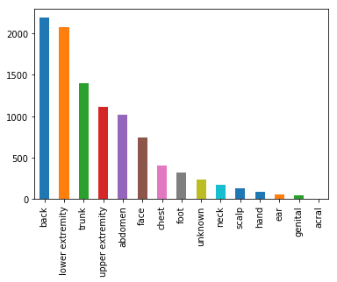
Fig. 4.1.5 Bar graph for localization

#Plotting age vs count of people with lesions
skin_df[‘age’].hist(bins = 40)
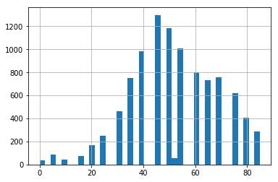
Fig.4.1.6 Histogram for Plotting age Vs Count of people with Lesion

# Comparing gender vs people with lesions
skin_df[‘sex’].value_counts().plot(kind=’bar’)
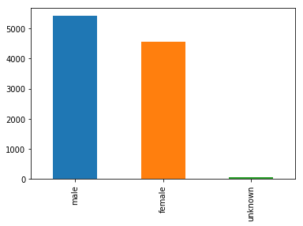
Fig. 4.1.7 Bar Graph for comparing Gender Vs people with Lesion

# Age vs lesion type
sns.scatterplot(‘age’, ‘cell_type_idx’, data = skin_df)
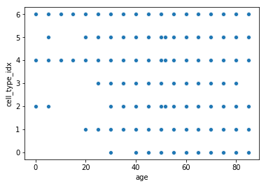
Fig. 4.1.8 Scatterplot Age Vs Lesion type

4.1.7 Train – Test data split
features = skin_df.drop(columns=[‘cell_type_idx’], axis=1)
target = skin_df[‘cell_type_idx’]
x_train_o, x_test_o, y_train_o, y_test_o = train_test_split(features, target, test_size=0.20, random_state=1234)

4.1.8 Normalization
x_train = np.asarray(x_train_o['image'].tolist())
x_test = np.asarray(x_test_o['image'].tolist())
x_train_mean = np.mean(x_train)
x_train_std = np.std(x_train)
x_test_mean = np.mean(x_test)
x_test_std = np.std(x_test)
x_train = (x_train - x_train_mean)/x_train_std
x_test = (x_test - x_test_mean)/x_test_std
y_train = to_categorical(y_train_o, num_classes=7)
y_test = to_categorical(y_test_o, num_classes=7)

4.1.9 Mobilenet CNN model building
K.image_data_format()
def mobilenet_block(x, filters, strides):
x = DepthwiseConv2D(kernel_size=3, strides=strides, padding='same')(x)
x = BatchNormalization()(x)
x = ReLU()(x)
x = Conv2D(filters=filters, kernel_size=1, strides=1, padding='same')(x)
x = BatchNormalization()(x)
x = ReLU()(x)
return x

INPUT_SHAPE = 224, 224, 3
input = Input(INPUT_SHAPE)
x = Conv2D(filters=32, kernel_size=3, strides=2, padding='same')(input)
x = BatchNormalization()(x)
x = ReLU()(x)
x = mobilenet_block(x, filters=64, strides=1)
x = mobilenet_block(x, filters=128, strides=2)
x = mobilenet_block(x, filters=128, strides=1)
x = mobilenet_block(x, filters=256, strides=2)
x = mobilenet_block(x, filters=256, strides=1)
x = mobilenet_block(x, filters=512, strides=2)

for _ in range(5):
x = mobilenet_block(x, filters=512, strides=1)
x = mobilenet_block(x, filters=1024, strides=2)
x = mobilenet_block(x, filters=1024, strides=1)
x = AvgPool2D(pool_size=7, strides=1)(x)
flattened = Flatten()(x)
output = Dense(units=7, activation='softmax')(flattened)
model = Model(inputs=input, outputs=output)
model.summary()
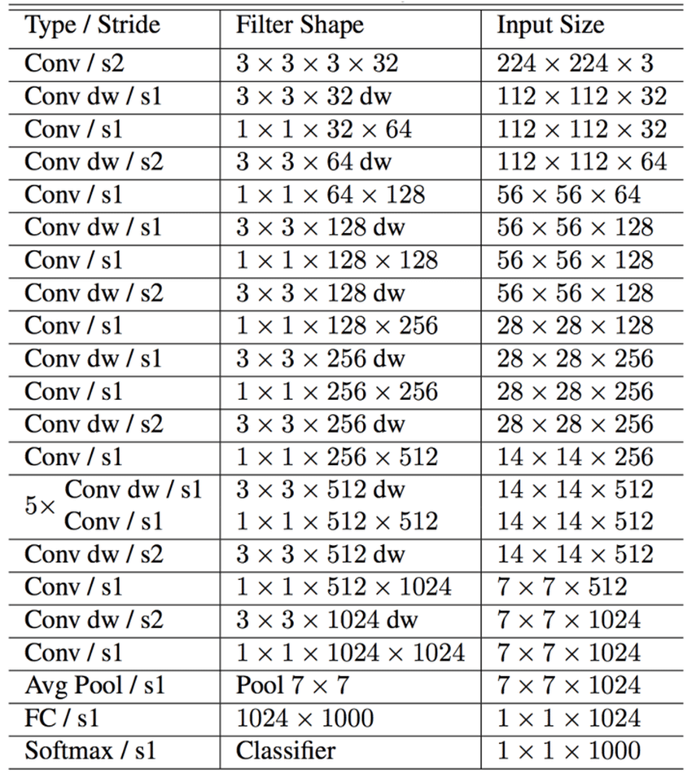
Fig.4.1.9 MobileNet model

#Optimizer
optimizer = Adam(lr=0.001,
beta_1=0.9, beta_2=0.999,
epsilon=None, decay=0.0, amsgrad=False)

#Compiling the model
model.compile(optimizer = optimizer,
loss = “categorical_crossentropy”,
metrics = [“accuracy”])

#Setting a learning rate annealer
leraning_rate_reduction = ReduceLROnPlateau(monitor=’accuracy’ , patience=3, verbose=1, factor=0.5, min_lr=0.00001)

#Data augmentation for preventing overfitting
datagen = ImageDataGenerator( featurewise_center=False, samplewise_center=False, featurewise_std_normalization=False, samplewise_std_normalization=False, zca_whitening=False, rotation_range=10, zoom_range = 0.1, width_shift_range=0.1, height_shift_range=0.1, horizontal_flip=False, vertical_flip=False)
datagen.fit(x_train)

4.1.10 Training the model
epochs = 15
batch_size = 20
history = model.fit_generator(datagen.flow(x_train,y_train, batch_size=batch_size),
epochs = epochs, validation_data = (x_validate,y_validate), verbose = 1, steps_per_epoch=x_train.shape[0] // batch_size , callbacks=[learning_rate_reduction])
4.1.11 Calculating accuracy
loss, accuracy = model.evaluate(x_test, y_test, verbose=1)
loss_v, accuracy_v = model.evaluate(x_validate, y_validate, verbose=1)
print(“Validation: accuracy = %f; loss_v = %f” %(accuracy_v, loss_v)
print(“Test: accuracy = %f; loss_v = %f” %(accuracy, loss)

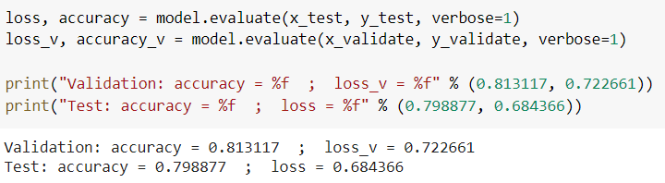
Fig.4.1.10 Calculating Accuracy

4.1.12 Plotting confusion matrix
def plot_confusion_matrix(cm, classes, normalize=False, title='Confusion matrix', cmap=plt.cm.Blues):
plt.imshow(cm, interpolation='nearest', cmap=cmap)
plt.title(title)
plt.colorbar()
tick_marks = np.arange(len(classes))
plt.xticks(tick_marks, classes, rotation=45)
plt.yticks(tick_marks, classes)
if normalize:
cm = cm.astype('float') / cm.sum(axis=1)[:, np.newaxis]
thresh = cm.max() / 2
tick_marks = np.arange(len(classes))
plt.xticks(tick_marks, classes, rotation=45)
plt.yticks(tick_marks, classes)

for i, j in itertools.product(range(cm.shape[0]), range(cm.shape[1])):
plt.text(j, i, cm[i, j], horizontalalignment="center", color="white" if cm[i, j] > thresh else "black")
plt.tight_layout()
plt.ylabel('True label')
plt.xlabel('Predicted label')

# Predict the values from the validation dataset
Y_pred = model.predict(x_validate)
# Convert predictions classes to one hot vectors
Y_pred_classes = np.argmax(Y_pred,axis = 1)
# Predict the values from the validation dataset
Y_pred = model.predict(x_validate)
# Convert validation observations to one hot vectors
Y_true = np.argmax(y_validate,axis = 1)
# compute the confusion matrix
confusion_mtx = confusion_matrix(Y_true, Y_pred_classes)
# Convert predictions classes to one hot vectors
Y_pred_classes = np.argmax(Y_pred,axis = 1)
# plot the confusion matrix
plot_confusion_matrix(confusion_mtx, classes =range(7))

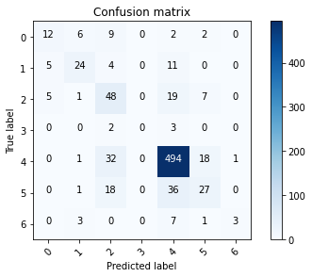
Fig.4.1.11 Confusion Matrix

4.2 UI(User Interface) CODING
4.2.1 Importing essential packages
import tkinter as tk
from PIL import ImageTk, Image
from tkinter import filedialog
from tkinter import Label
from keras.models import load_model
from matplotlib import pyplot as plt
import cv2
import numpy as np
from tkinter.messagebox import *
from tkinter import *

4.2.2 Prediction code
model=load_model("/home/adminpc/Downloads/skinLesionmodel.h5")
def UploadAction(event=None):
filename = filedialog.askopenfilename()
#print(filename)

img = cv2.imread(filename)
load = Image.open(filename)
load = load.resize((300, 300), Image.ANTIALIAS)
render = ImageTk.PhotoImage(load)
img2 = Label(image=render)
img2.image = render
img2.place(x=100, y=160)

img.resize(1, 75, 100, 3)
les_type = np.argmax(model.predict(img), axis=-1)
#print(les_type)
Label(root, text="The lesion type is: ").place(x=100, y = 500)
Label(root, text=lesionTypeMap[les_type[0]]).place(x=300, y=500)

4.2.3 User Interface
root = tk.Tk()
root.title("Skin Lesion Classification")
root.minsize(750, 1000)
root.resizable(width=True, height = True)

req_font = (“MS Serif”, 12)
heading = Label(root, text="Select image").place(x=100, y=100)
heading.configure(font=req_font)
button = tk.Button(root, text='Upload image', command=UploadAction).place(x=100, y=125)
root.mainloop()

4.3 TESTING
Software testing is a critical element of software quality assurance and represents the ultimate review of specification, design and coding. The increasing visibility of software as a system element and attendant costs associated with a software failure are motivating factors for we planned, through testing.

4.3.1 Test Cases

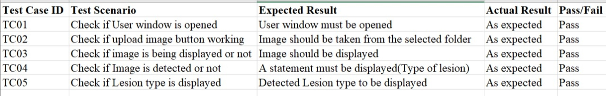
Fig.4.3.1 Test cases

4.4 DATASET TRAINING IMAGES

After tuning various parameters and compiled the model we fit the model using 15 epochs with a batch size of 20.
The number of epochs is a hyper parameter that defines the number times that the learning algorithm will work through the entire training dataset. The batch size is a number of samples processed before the model is updated. The number of epochs is the number of complete passes through the training dataset.
So we chose the epochs and batch size in such a way that our model could train sufficiently.

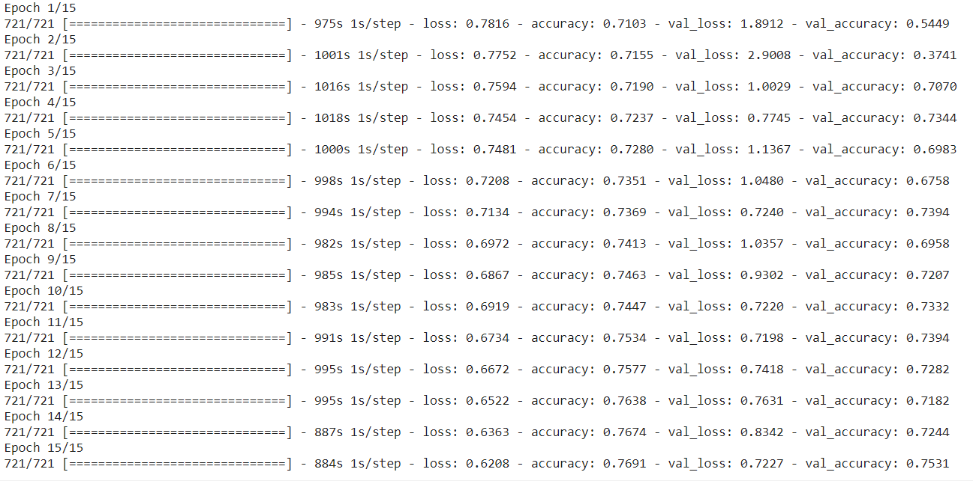

Fig.4.4.1 Dataset Training Images

4.5 INPUT IMAGES

Command to run the project

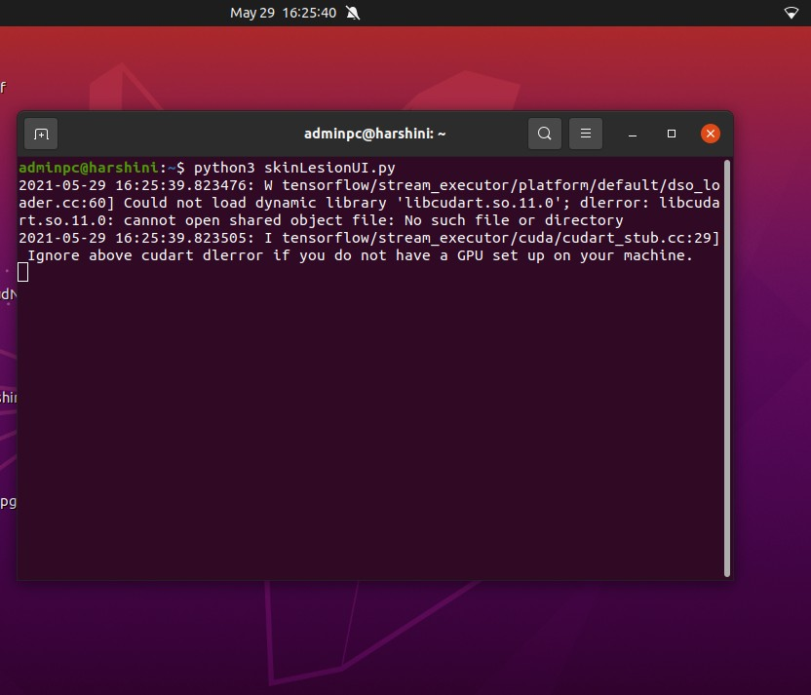
Fig.4.5.1 Command to run the Project

Upload the images

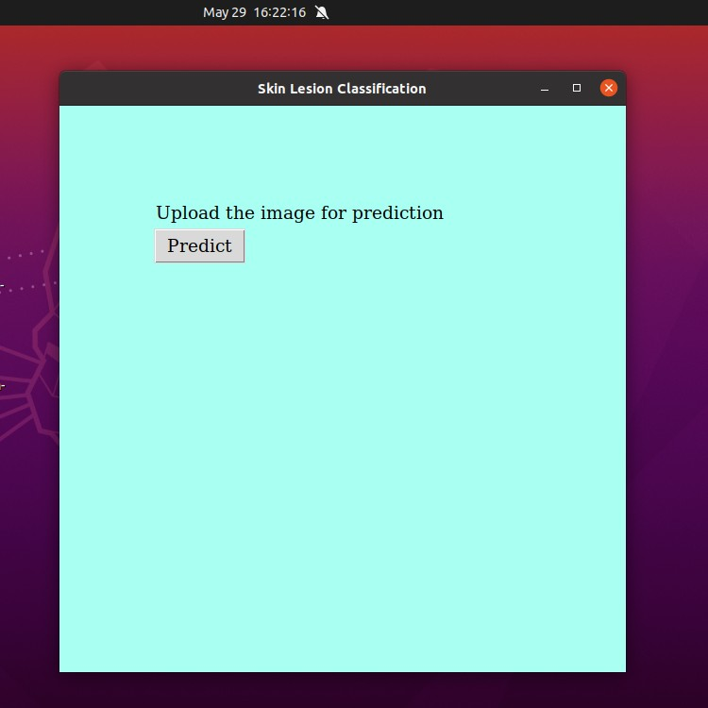
Fig.4.5.2 Upload the images
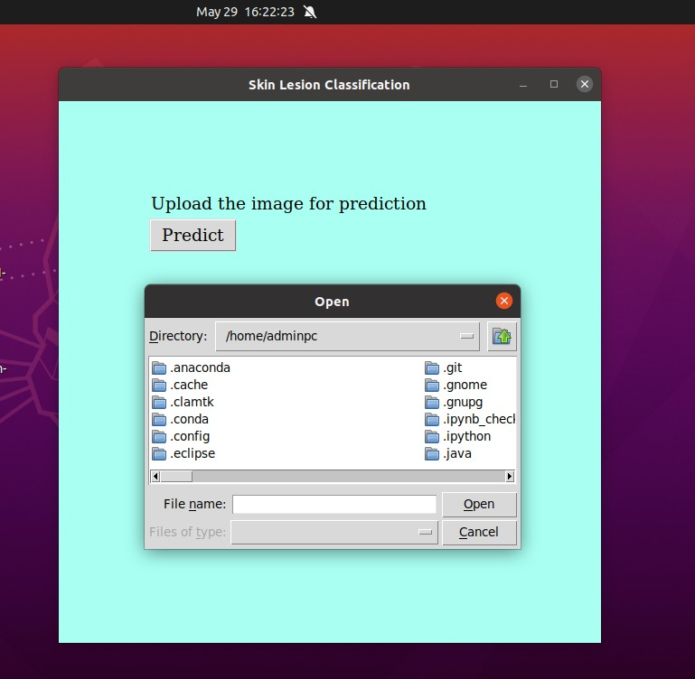
Fig.4.5.3 Selecting file to upload image

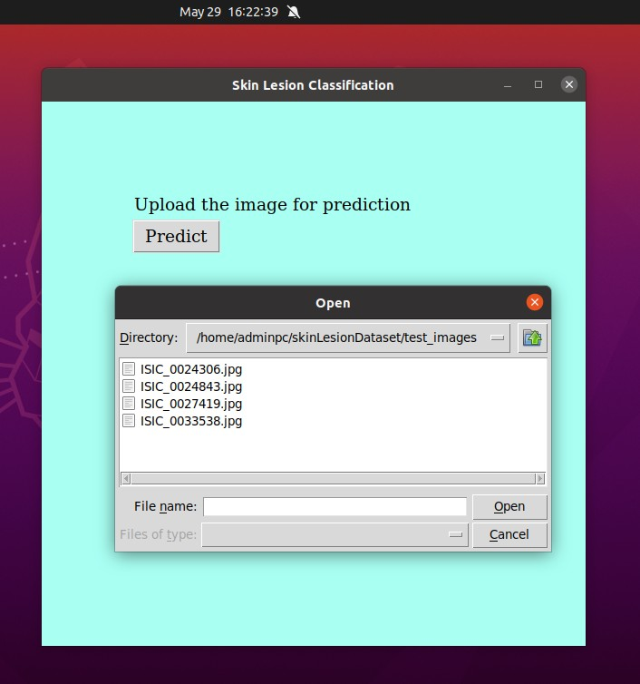
Fig.4.5.4 Selecting Image to upload
4.6 OUTPUT IMAGES

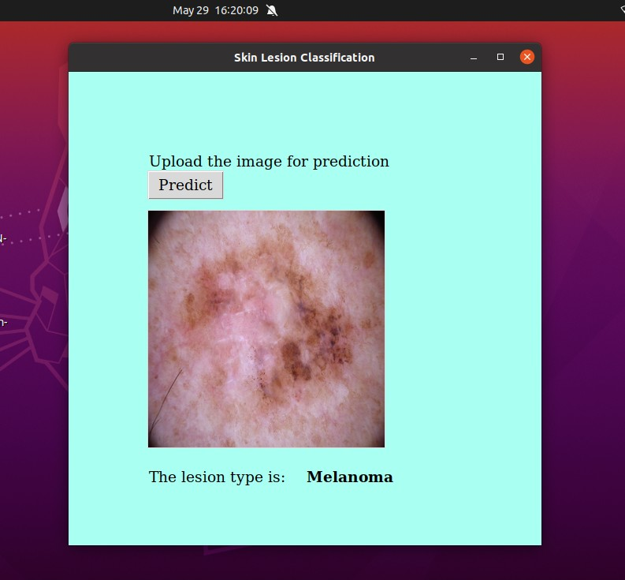
Fig.4.6.1 Predicting Lesion Type(1)

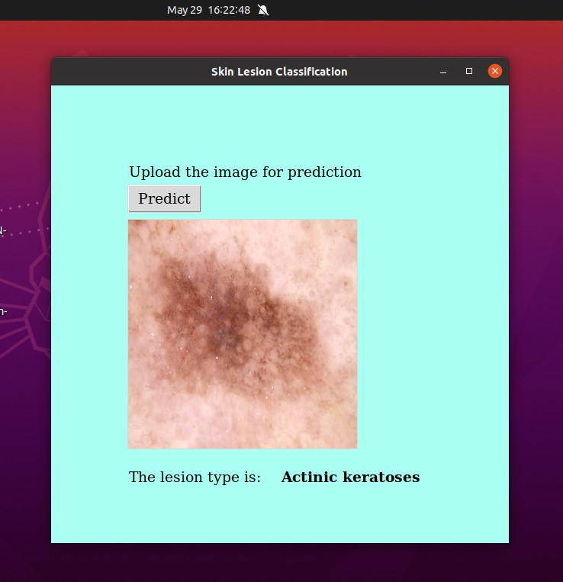
Fig.4.6.2 Predicting Lesion Type(2)

5. CONCLUSION AND FUTURE SCOPE
This application helps doctor to classify skin lesions to their respective type among 7 classes accurately. Skin cancer is a major threat to human health and early identification can save a person’s life but this rapid classification / identification remains difficult in many parts of the world due to lack of necessary infrastructure. Training of neural networks for automated diagnosis of pigmented skin lesions is hampered by the small size and lack of diversity of available dataset of dermatoscopic images. This problem was tackled by HAM10000 dataset which was formed by collecting images from different populations, acquired and stored by different modalities. After the training of model using deep convolutional neural network we achieved an accuracy of 81%.
The future enhancement of this application could be to
- Further increase the accuracy
- Present a treatment plan
6. REFERENCES
[1] Saket S. Chaturvedi, Kajol Gupta, Prakash. S. Prasad, “Skin Lesion Analyser: An Efficient Seven-Way Multi-Class Skin Cancer Classification Using MobileNet”,May. 2020. (BasePaper)
https://arxiv.org/abs/1907.03220
[2] M. A. A. Milton, “Automated Skin Lesion Classification Using Ensemble of Deep Neural Networks in ISIC 2018: Skin Lesion Analysis Towards Melanoma Detection Challenge,” Jan. 2019.
[3] Kawahara J, Hamarneh G. Multi-resolution-Tract CNN with Hybrid Pretrained and Skin Lesion Trained Layers. In: Wang L, Adeli E, Wang Q, Shi Y, Suk HI (eds) Machine Learning in Medical Imaging. MLMI 2016. https://doi.org/10.1007/978-3-319-47157-0_20
[4] Burroni M et al. Melanoma computer-aided diagnosis: reliability and feasibility study. Clin. Cancer Res. 2004; https://doi.org/10.1158/1078-0432.CCR-03-0039
[5] Kawahara J, Hamarneh G. Multi-resolution-Tract CNN with Hybrid Pretrained and SkinLesion Trained Layers. In: Wang L, Adeli E, Wang Q, Shi Y, Suk HI Machine Learning. https://doi.org/10.1007/978-3-319-47157-0_20
[6] M. A. A. Milton, “Automated Skin Lesion Classification Using Ensemble of Deep Neural Networks in ISIC 2018: Skin Lesion Analysis Towards Melanoma Detection Challenge”.
[7] Howard AG et al. MobileNets: Efficient Convolutional Neural Networks for Mobile Vision Applications. arXiv Prepr. https://arxiv.org/abs/1704.04861. 2017.
[8] “A Mobile Automated Skin Lesion Classification System” by Kiran Ramlakhan, Yi Shang in 2011 IEEE 23rd International Conference. https://ieeexplore.ieee.org/abstract/document/6103318
[9] Adria Romero Lopez, Xavier Giro-i-Nieto, Jack Burdick, Oge Marques “Skin lesion classification from dermoscopic images using deep learning techniques” in 2017 13th International Conference on Biomedical Engineering, IEEE. https://ieeexplore.ieee.org/xpl/conhome/7890909/proceeding
[10] Jordan Yap, William Yolland, Philipp Tschandl “Multimodal skin lesion classification using deep learning” https://doi.org/10.1111/exd.13777

